First announcement
12th LOWRAD International Conference, Warsaw 12-13, December, 2016

“The Effects of Low Doses and Very Low Doses of Ionizing Radiation on Human Health and Biotopes”

will be held in Warszawa, Poland

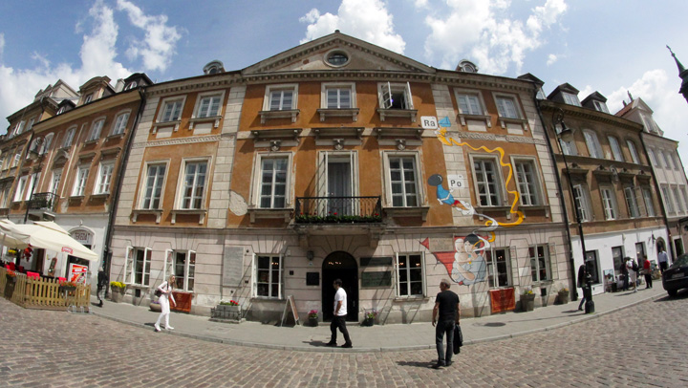Maria Skłodowska-Curie Museum, Warszawa

Dear Madame, Sir,
On behalf of the organizing committee of the 12th LOWRAD International Conference “The Effects of Low and Very Low Doses of Ionizing Radiation on Human Health and Biotopes”, which will be held in Warsaw, Poland, on 12-13 December 2016, I cordially invite You to take part in one of the most important international conferences dedicated to low doses of ionizing radiation. We shall be delighted to host you in the hometown of Maria Skłodowska-Curie - the “Mother of radioactivity”, the twice winner of Nobel Prize, whose 150th anniversary of the birth will be solemnly celebrated next year, 2017. In the Old Town of Warsaw at 16 Freta Street, you can visit the unique biographical museum of Maria Skłodowska-Curie, in the house where she was born. This museum and many other tourist attractions, along with the atmosphere of modern lively European capital, make Warsaw worth seeing. So please come, see and enjoy. We are looking forward to seeing you in Warsaw.

Organizers:

World Council of Nuclear Workers (WONUC)
Low Radiation International Network (LOWRAD)
Polish Radiation Research Society (PTBR)
Institute of Nuclear Chemistry and Technology (ICHTJ)

Registration and call for papers
Abstract and registration forms please send to: s.sommer@ichtj.waw.pl

Deadline for registration form submission is 21st of November 2016.
We appreciate earlier submission of registration form.

Deadline for abstract form submission is 1st of December 2016.
We appreciate earlier submission of abstract form.

Venue
Institute of Nuclear Chemistry and Technology, 16 Dorodna st, 03-195, Warsaw, Poland

Payment
Normal fee 300 Euro, includes: lunches, coffee breaks, conference dinner, conference materials. Students fee 150 Euro.
Payment preferable by bank transfer till 1sth of December 2016.

Hotel accommodation
You should book your hotel room by yourself.. The information on Warsaw hotels will be prepared soon.

Topics
• Autophagy: a double-edged sword in cellular radiation response;
• Biological effects of environmental and extraterrestrial UV radiation
• Biomarkers of low dose exposure
• Cell adhesion/migration in response to irradiation
• Cell cycle control and apoptosis
• Chromatin modifications and DNA damage response
• Childhood radiation exposure
• Computer simulation and modeling for low dose radiation risk
• Delayed and epigenetic effects of ionising radiations
• Detection and genotoxic consequences of complex radiation damage
• DNA repair and misrepair after irradiation, signal transduction
• DNA repair and mutagenesis
• Genetic susceptibility
• Hormesis
• Hyperthermia
• Impact of dose rate on radiation effects
• Immunological effects of radiation
• Induction of secondary cancers by ionizing radiation
• Long term effects of radiation of the medical application of radiation
• Low dose effects, protracted dose effects
• Microdosimetry and nanodosimetry
• Microenvironment modulation of radiation response
• Micro-array and proteomic analysis
• Models for radiation induced carcinogenesis
• Modification of radiation effects on mammalian tissues
• Molecular biophysical approaches of radiation effects
• Molecular and cellular responses
• Non cancer effects
• Non genotoxic effects of radiation and degenerative diseases
• Non-targeted effects of ionising radiation: adaptive response, bystander effects, genomic and/or chromosomal instability
• Occupational and environmental low dose and protracted exposure
• On the intrinsic radiation sensitivity of stem cells and tissues
• Origin of chromosome aberration formation with low- and high-LET radiation
• Oxidative metabolism and the radiation response
• Oxygen effect revisited: ROS–antioxidants–hypoxia–O2 effect-radiosensitiser – NO
• Photo-dermatology, photo-carcinogenesis
• Radiation carcinogenesis, mutagenesis
• Radiation effects on non-human biota
• Radiation epidemiology
• Radiation-induced inter- and intracellular signalling
• Radiation risk and its significance in the total risk structure
• Radiation-induced clustered DNA damage; biological relevance
• Radiation protection
• Radiation physics and chemistry
• Radiation quality: differences and similarities
• Radioecology and dosimetry of biota
• Radioprotectors and radiosensitizers
• Radon exposure and remediation
• Repair of radiation induced DNA double strand breaks in cells, repair pathways, new aspects, signaling
• Residue management
• Role of the microenvironment in tissue/tumor response to irradiation: Inflammation/Stroma
• Stem cell biology: relevance for radiation response of normal and tumor tissue
• The bridge between radiobiology and epidemiology in predicting health risks
• Threshold approaches: praises and critics
• Tumor angiogenesis, cytokines, chemokines
• Use of probes to detect DNA damage processing in cells
• UV-irradiation and nucleotide excision repair
• Validity of the linear – non-threshold model (LNT)
• Water radiolysis: simulations towards understanding biological responses

Additional information
For additional information contact dr Sylwester Sommer, s.sommer@ichtj.waw.pl
The www page will start soon.

Tentative Program

Monday 12th of December
10.00 – 11.30 – Seminar on low doses of radiation and radiological protection for the PhD students (radiation chemists) and employees of ICHTJ – two speakers
11.40 – 12.30 Meeting of the former Marie Curie Prize Awardees and invited persons – discussion about the LOWRAD as an association
12.40 – 13.30 Lunch
13.30 – 13.45 Opening of the LOWRAD Conference
13.45 – 14.00 N. Foray (France): The contribution of Dorota Słonina to... - Marie Curie Prize Ceremony
14.00 – 15.00 D. Słonina Marie Curie Prize Lecture
15.00 – 15.30 Break, poster session
15.30 – 16.30 Session 1
16.30 - 16.45 Break
16.45 – 18.00 Panel discussion 1 (round table, brain storming)
20.00 Conference dinner at the city center

Tuesday 13th of December
9.00 – 10.30 Session 2
10.30 – 11.00 Break
11.00 – 12.30 Session 3
12.30 – 13.00 Summary of poster session, 5 min short presentation of posters
13.00 – 14.00 Lunch
14.00 – 15.00 Session 4 (optional, it will take place if necessary – depending on the number of participants)
15.00 – 15.30 Synthesis Debate, Conference closing

